**UI Design**

The application that I decided to re-create and improve the design of is Taco Bell app. In my opinion their design is not bad, but I believe I could simplify it and make it more interactive. I believe their app would benefit from a re-design. I chose this app as I am a user and order from Taco Bell from time to time.

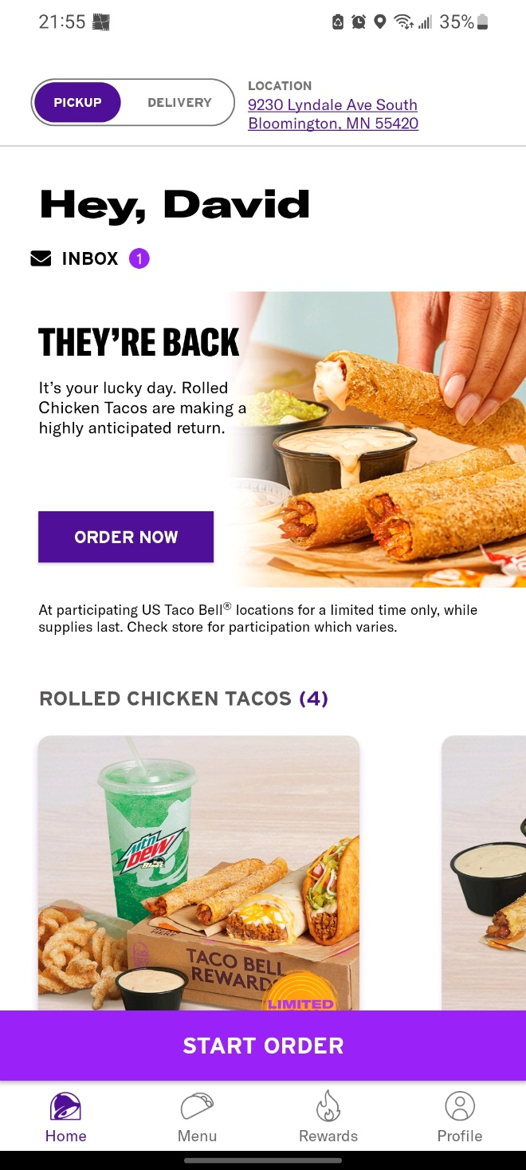

Original Taco Bell main menu screen

1. Remove pickup and delivery switch button on top and add it as an interactive part for the new start order button.

2. Add the Rewards option right after the greeting instead of inbox (I never went into the inbox time, so it’s useless) and add the menu option next to it.

3. Move the profile icon to the top right corner instead of bottom right corner and remove the home option, which will eliminate the bottom panel. (When user goes to a different screen, I would add the option to go back on top left corner)

4. Instead of the “START ORDER” as a big button that takes a lot of space, I would add the plus sign which is interactable on the right bottom part of the screen (When user clicks on the plus sign it gives them an option to start order and ask if it’s a delivery or pickup)

Updated Taco Bell main menu screen

I chose to make the changes above because I believe they will make the user experience more pleasant and interactive while being simple and easy to navigate. The first change is to remove the switch button for delivery and pickup options with the address, as in my opinion it clusters the space. It can also be unpleasant when you open the app, and the delivery option is visible with your address, and someone might see where you live. I would add these options to the newly created plus sign for starting the order, which I will describe later. The next change is to remove the inbox icon below the greeting. I like the greeting as it makes the app more personal but at least for me as a user of this app, the inbox option there is useless. I never clicked on it and as a change I would add it to the profile as an option to click on it there. Then I would add the rewards and menu options from the bottom under the greeting and I would keep the new products on the main page as they are right now. Next change is the removal of the “Home” button and moving the “Profile” button from the bottom panel to the top right corner. The profile is located on the top right corner in many apps, and it would add to the familiarity of the app from the user since they most likely use apps such as Gmail or YouTube, that have the profile positioned in the top right corner. This would also eliminate the whole bottom panel and would allow for more space on the screen to be dedicated to new products, other updates or features. The last change I would make is to eliminate that huge purple button for starting a new order. In my opinion, the button takes way too much space and even though it’s simplistic for users to understand the functionality, it does not look good. I would replace it with a plus sign on the right bottom part of the screen. I would keep the same color scheme to stay consistent with the rest of the app. This plus sign would be interactable and allow users to start new orders. When the user clicks the button, it will open a small pop-up view right next to it asking if the order will be a delivery or a pickup. I will try to recreate the new version of the app to better showcase the changes.

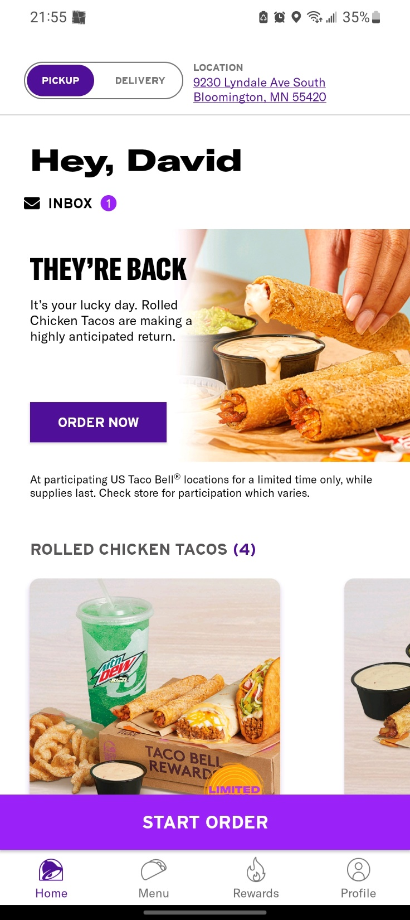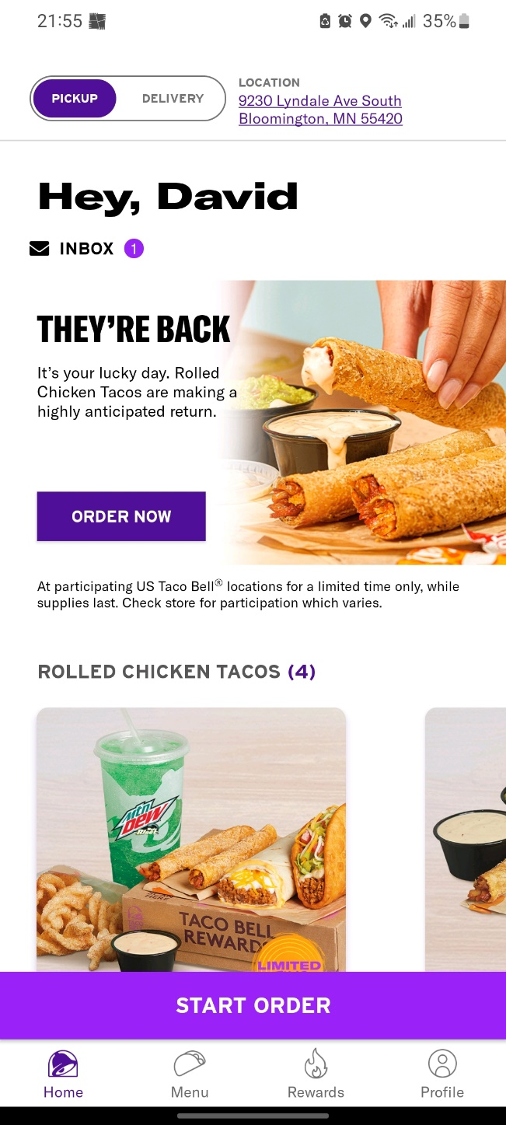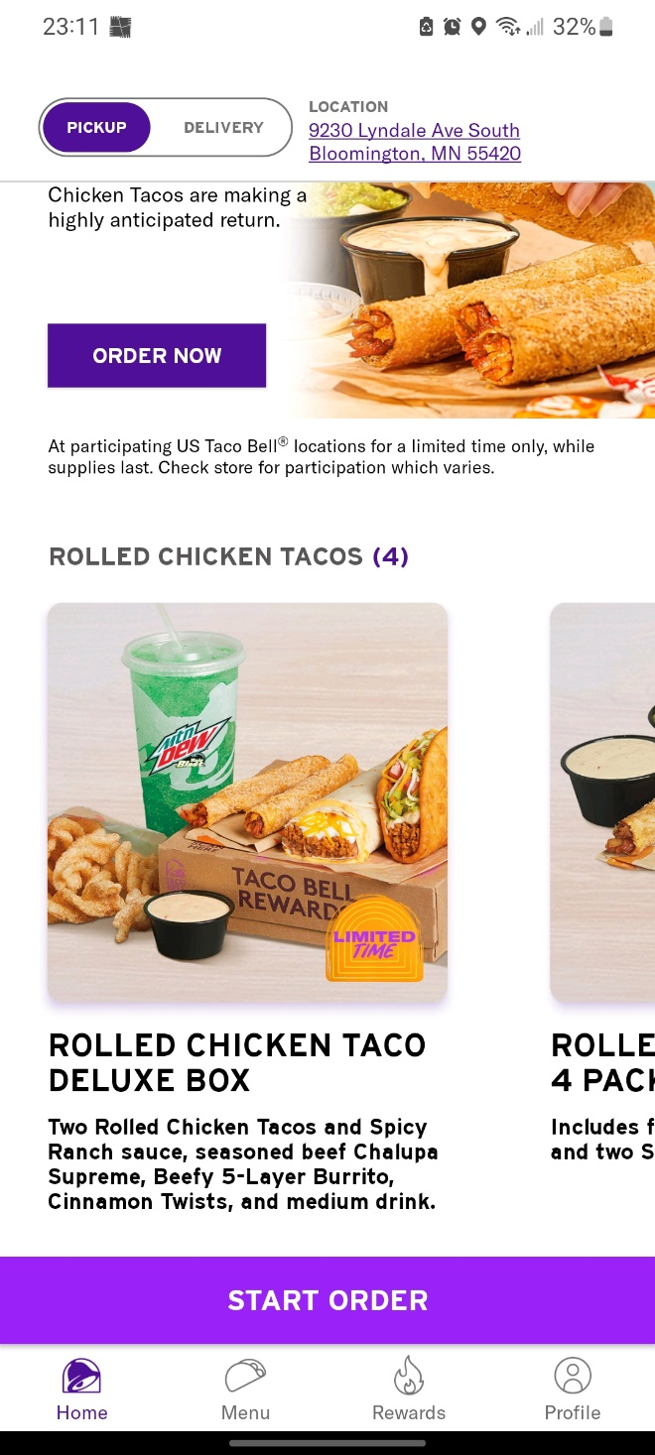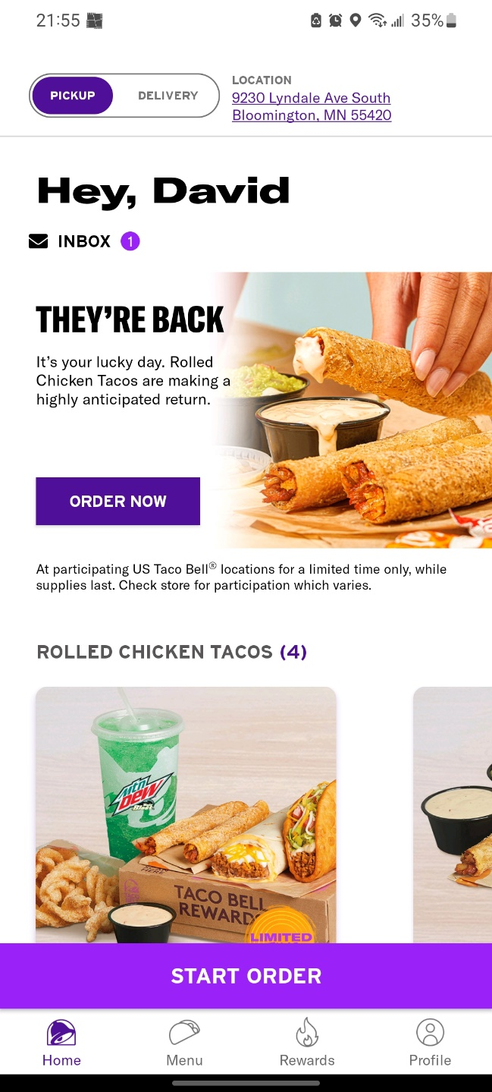

Menu

Rewards

Delivery  
Pickup

Updated Taco Bell app main screen